**Derived Tables**

* Created with the help of the Select statement.
* Appears in the FROM clause of a query.
* Scope of derived table is limited to the outer Select query that created it.
* Cannot be used further outside the scope of outer select query.
* It is different from the temporary table in the way that in case of temporary table, first we have to create a temporary table, inserts the data into the table, select the data from the temporary table and then we have to drop the temporary table.
* But in case of derived table, SQL Server itself creates and populates the table in the memory and we can directly use it.
* Also we don’t need to drop it.
* But it can only be referenced by the outer Select query that created it.
* Also since it is reside in the memory itself; it is faster than Temporary tables which are created in the temp database.
* When you are required to perform some complex query and result of inner query work as table for outer query.

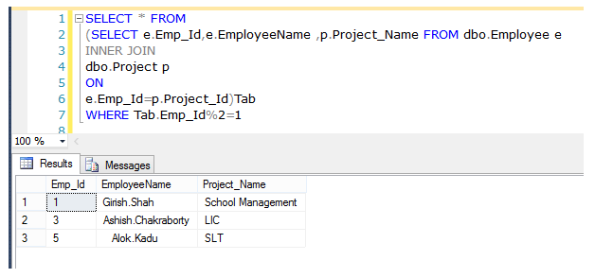

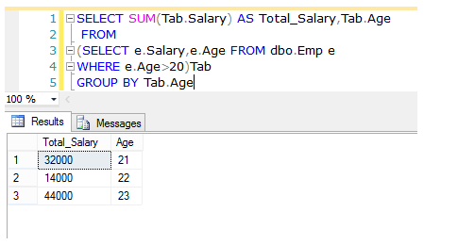

In this query we will select the LastName and EmployeeId columns from the derived table. Normally we would select a table in the database, but in this case we create a special table for it. To create a derived table, we use the SELECT and FROM statements in parenthesis to select all columns in the Employee table. We then use the WHERE clause to filter entries from ‘Australia’ and name the derived table ‘EmployeeDerivedTable. The derived table is now finished but the outer query still has minor things to specify. We use the WHERE clause to select entries with a DepartmentId of ’33′ and then to order the results by LastName.

|  |  |
| --- | --- |
| 1  2  3  4  5  6 | SELECT LastName, EmployeeId  FROM      (SELECT * FROM Employee       WHERE Country = 'Australia') AS EmployeeDerivedTable  WHERE DepartmentId = 33  ORDER BY LastName |

What we are doing is first getting the result set from the derived table (the SELECT statement in the FROM clause). Once we have that result set, we can perform the SELECT on the derived table, returning our results.